Project Design Phase Problem – Solution Fit Template

Date | 29 September 2026
Team ID | SWTID-2026-3894
Project Name | AI BLOGNEST API
Maximum Marks | 2 Marks

Problem – Solution Fit Template:
Problem:
Many users struggle to find reliable, personalized, and easy-to-understand blog content because information is scattered across different platforms. Content creators also face difficulties in generating ideas, organizing articles, and reaching the right audience.
Solution:
AI BlogNest API provides an AI-powered blogging platform that helps users discover, create, organize, and manage blog content in one place. The system can use AI to generate content ideas, suggest relevant topics, improve writing, and provide personalized recommendations based on user interests. With a simple interface and centralized content management, AI BlogNest API reduces the effort required to create and consume useful blog content while improving the overall blogging experience.
Target :
Users Students Bloggers and content creators Beginners in blogging Freelance writers Small businesses and marketers
Proposed Solution :
AI BlogNest API is an AI-powered blogging platform that helps users generate, edit, organize, and manage blog content efficiently

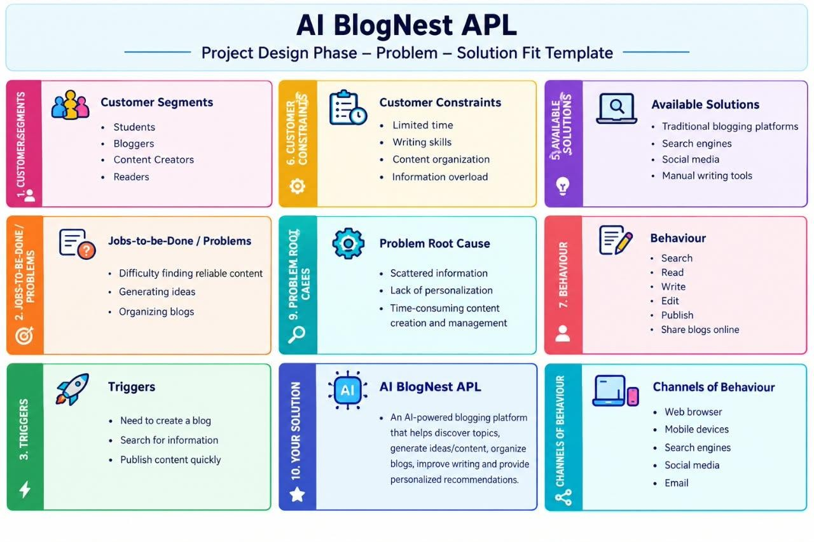
Template:

References:
- https://www.ideahackers.network/problem-solution-fit-canvas/
- https://medium.com/@epicantus/problem-solution-fit-canvas-aa3dd59cb4fe

